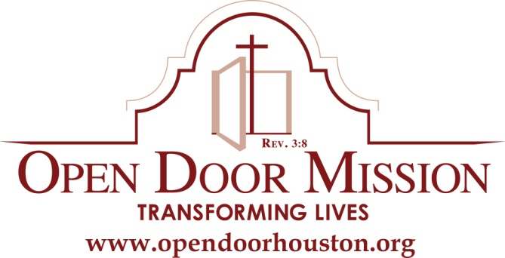
Media Contact:
Butch Mangum
713-921-7520
tmangum@opendoorhouston.org

** MEDIA ALERT **

Open Door Mission’s Semi-Annual Field Day

Saturday, April 25, 2015

What: Houston, TX – On Saturday, April 25th from 9:00 a.m. to 2:00 p.m., Open Door Mission in conjunction with the Houston Parks Department will be hosting a luncheon and softball, basketball, horseshoes, bean bag toss and board games at Eastwood Park at 5000 Harrisburg Boulevard, Houston, Texas 77011.
Open Door residents will have an opportunity to engage in fellowship with family, staff and local community leaders. It is an opportunity for the men to engage in drug free activities and realize how drug free can be with family and friends.

We are honored to have Constable Martinez, Chief Armando Tello from Precinct 6 at the event.

WHEN: Saturday, April 25, 2015
9:00 am – 2:00 pm

WHERE: Eastwood Park
5000 Harrisburg Boulevard
Houston, Texas 77011

Photo Opportunities:
Open Door Mission staff, residents of the Mission, their families and the public enjoying Houston’s East End redevelopment.
Interview Opportunities:
    - Tommy Thompson, President & CEO of Open Door Mission
    - Open Door Mission residents and alumni

About Open Door Mission

Founded in 1954 as a downtown Houston homeless shelter and soup kitchen, Open Door Mission is a faith- and evidence-based recovery and rehabilitation facility dedicated to transforming the lives of the most severely addicted, destitute, homeless and disabled men in our community. We received non-profit status in 1985 and employ a multifaceted mind, body and spiritual approach with programs of recovery, learning and healing.

Established in 1991, the Russell M. Scott, Jr. M.D. Convalescent Care Center provides homeless, destitute and veteran men a safe, short-term environment in which to convalesce from surgery, injury or illness. While recovering on our campus, we work with men to address the issues that led to homelessness and assemble an array of social services to help get them back on their feet and end the cycle of homelessness.

Our Alan and Ann Craft DoorWay Drug/Alcohol Recovery program, established in 1993, focuses on overcoming insobriety, understanding one’s self, and developing a Christian understanding and faith by which to continue in a sober service to others.

Recognizing that a lack of education is a key factor when addressing poverty, the Education Center continues the care and support by providing educational opportunities to those in need of GED certification, literacy classes, tutoring and training in basic computer skills. The Education Center is also open to men and women from the community.

The men who come to the Mission are desperate for help and willing to receive it. Whether alcohol and drugs came before or after an event that led to loss of home, job and dignity, the addictions must be addressed before an individual can begin working toward self-sufficiency. Residents come from all walks of life but share one reality: the ways of the past no longer work and they need help in creating a new, independent and sober future.

For more information about Open Door Mission, visit www.opendoorhouston.org.
The alcohol and drug treatment and recovery services offered at Open Door Mission are exclusively religious in nature and are not subject to licensure or regulation by the Texas Commission on Alcohol and Drug Abuse. This program offers only nonmedical treatment and recovery methods such as prayer, moral guidance, spiritual counseling and scriptural study.
-30-

